1.

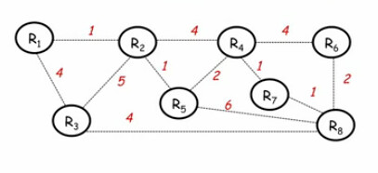

**Sol**:

|  |  |  |  |  |  |  |  |  |
| --- | --- | --- | --- | --- | --- | --- | --- | --- |
|  | **0** | **1** | **2** | **3** | **4** | **5** | **6** | **7** |
| **Shortest Path Set** | R8 | R8, R7 | R8, R7, R6 | R8, R7, R6, R4 | R8,R7, R6,R4,R3 | R8, R7,R6, R4, R3, R2 | R8, R7,R6,R4, R3, R2, R5 | R8, R7 , R6, R4, R3, R2, R1 |
| **Candidate Set** | R3, R5, R6,R7 | R3, R5, R6, R4 | R3, R5, R4 | R3, R5, R2 | R2, R5, R1 | R1, R5 | R1 | - |
| **Add** | R7 | R6 | R4 | R3 | R2 | R5 | R1 | DONE |

2.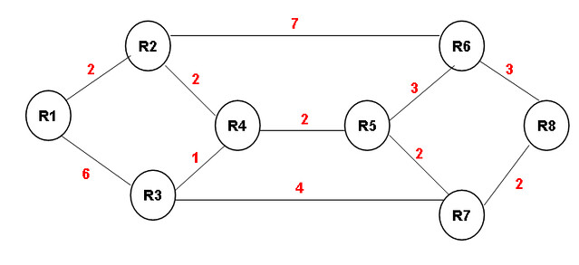

**Sol:**

|  |  |  |  |  |  |  |  |  |
| --- | --- | --- | --- | --- | --- | --- | --- | --- |
|  | **0** | **1** | **2** | **3** | **4** | **5** | **6** | **7** |
| **Shortest Path Set** | R8 | R8, R7 | R8, R7, R6 | R8, R7, R6, R5 | R8, R7, R6, R5, R3 | R8, R7, R6, R5, R4, R3 | R8, R7, R6, R5, R4, R3, R2 | R8, R7, R6, R5, R4, R3, R2, R1 |
| **Candidate Set** | R6, R7 | R6, R5, R3 | R5, R3, R2 | R3, R2, R4 | R4, R2, R1 | R2, R1 | R1 | - |
| **Add** | R7 | R6 | R5 | R3 | R4 | R2 | R1 | DONE |

3.

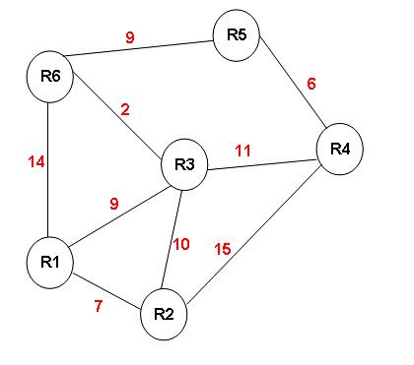

**Sol:**

|  |  |  |  |  |  |  |
| --- | --- | --- | --- | --- | --- | --- |
|  | **0** | **1** | **2** | **3** | **4** | **5** |
| **Shortest Path Set** | R1 | R1, R2 | R1, R2, R3 | R1, R2, R3, R6 | R1, R2, R3, R6, R5 | R1, R2, R3, R6, R5, R4 |
| **Candidate Set** | R2, R3, R6 | R3, R6, R4 | R6, R4 | R4, R5 | R4 | - |
| **Add** | R2 | R3 | R6 | R5 | R4 | DONE |

4.

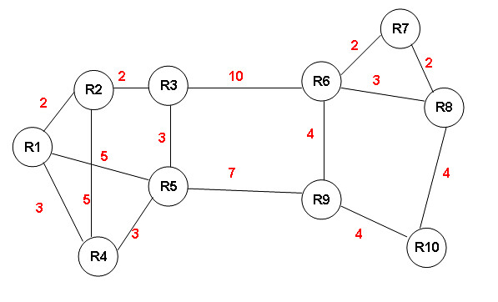

**Sol:**

|  |  |  |  |  |  |  |  |  |  |  |
| --- | --- | --- | --- | --- | --- | --- | --- | --- | --- | --- |
|  | 0 | 1 | 2 | 3 | 4 | 5 | 6 | 7 | 8 | 9 |
| **Shortest Path Set** | R1 | R1, R2 | R1, R2, R4 | R1, R2, R4, R3 | R1, R2, R4, R3, R5 | R1,R2,R4,  R3,R5,R9 | R1,R2,  R4,R3,  R5,R9,  R6 | R1,R2,  R4,R3,  R5,R9,  R6, 10 | R1,R2,R4,  R3,R5,R9,  R6, R10, R7 | R1,R2,R4,  R3,R5,R9,  R6, R10, R7, R8 |
| **Candidate Set** | R2, R4, R5 | R4, R5, R3 | R5, R3 | R5, R6 | R6,  R9 | R10,  R6 | R7, R8, R10 | R7, R8 | R8 | - |
| **Add** | R2 | R4 | R3 | R5 | R9 | R6 | R10 | R7 | R8 | DONE |

5.



**Sol:**

|  |  |
| --- | --- |
| **Router Number** | **Distance** |
| R1 | 6 R4 |
| R2 | 5 R5 |
| R3 | 4 |
| R4 | 2 R7 |
| R5 | 4R4 |
| R6 | 2 |
| R7 | 1 |

6.



**Sol:**

|  |  |
| --- | --- |
| Router | Distance |
| R1 | 12 R3 |
| R2 | 8 R4 |
| R3 | 6 R7 |
| R4 | 6 R5 |
| R5 | 4 R7 |
| R6 | 3 |
| R7 | 2 |

7.



**Sol**:

|  |  |
| --- | --- |
| Router | Distance |
| R1 | 20 R3 |
| R2 | 15 |
| R3 | 11 |
| R5 | 6 |
| R6 | 13 R3 |

8.



**Sol**:

|  |  |
| --- | --- |
| Router | Distance |
| R1 | 17 R5 |
| R2 | 19 R4 |
| R3 | 17 R6 |
| R4 | 14 R5 |
| R5 | 11 R9 |
| R6 | 7 R8 |
| R7 | 6 R8 |
| R8 | 4 |
| R9 | 4 |